Task 05: Networking and Security Operations with SIEM, Forensics, and Traffic Analysis

Prepared by: Kalash Mahajan
Date: 30th January 2026

1. Introduction
This report documents the practical execution of Task 05: Networking and Security Operations with SIEM, Forensics, and Traffic Analysis, performed in a controlled virtual lab environment.
The objective of this task was to bridge network-level visibility with SOC-style monitoring and incident analysis by combining packet-level inspection using Wireshark with centralized log monitoring using the ELK Stack (Elasticsearch, Logstash, Kibana).
The scope of work included:
- Capturing and analyzing real network traffic generated from a Linux virtual machine
- Identifying active protocols, top talkers, and communication patterns
- Deploying and validating an ELK-based SIEM setup on Ubuntu
- Ingesting system logs via Logstash and visualizing them in Kibana
- Simulating an unauthorized SSH access attempt from a separate Windows host
- Detecting and validating the incident using both system logs and SIEM queries
All observations, findings, and conclusions in this report are derived directly from hands-on experimentation, command-line execution, and captured evidence. Screenshots and logs are included at each stage to demonstrate alignment with real-world networking and SOC workflows rather than theoretical scenarios.

2. Objectives
The objectives of Task 05 were defined to bridge networking fundamentals with SOC-level security operations, using a hands-on lab-based approach. Each objective below directly maps to tasks performed during this exercise.
- Design and validate a logical subnet suitable for a small office environment, ensuring efficient IP utilization and scalability.
- Capture and analyze real network traffic using Wireshark to understand protocol behavior and communication patterns.
- Identify and troubleshoot network-level issues, including DNS resolution behavior and ICMP/TCP interactions.
- Deploy and configure a SIEM solution using the ELK Stack (Elasticsearch, Logstash, Kibana) on a Linux environment.
- Ingest and visualize system and authentication logs to enable centralized monitoring.
- Simulate a security incident (failed SSH authentication attempts) and perform log-based forensic analysis.
- Correlate network activity with SIEM data to demonstrate incident detection and investigation workflows.
- Perform basic threat hunting by querying logs for indicators such as repeated failed logins and suspicious access attempts.

3. Network Subnet Design
3.1 Requirements
The subnet was designed to represent a small office network with the following requirements:
- Approximately 20 end devices, including:
  - User workstations
  - Printers
  - Servers / network services
- Single LAN segment with internal communication
- Private IP addressing (RFC 1918)
- Simple structure suitable for monitoring and traffic analysis
- Future scalability without immediate reconfiguration
3.2 IP Addressing and CIDR Selection
- Chosen IP range: 192.168.52.0/24
- Address type: Private IPv4 address space
- CIDR notation: /24
Justification:
- Supports up to 254 usable IP addresses, which comfortably exceeds the current requirement of 20 devices.
- Commonly used in small enterprise and lab environments.
- Simplifies routing, monitoring, and troubleshooting during packet capture and SIEM analysis.
- Matches the actual lab environment used during traffic capture and ELK deployment.

3.3 Subnet Calculations
Parameter | Value
Network Address | 192.168.52.0
Subnet Mask | 255.255.255.0
CIDR | /24
Total IP Addresses | 256
Usable IP Addresses | 254
Network Address | 192.168.52.0
Broadcast Address | 192.168.52.255
Usable Host Range | 192.168.52.1 – 192.168.52.254
This configuration ensures sufficient address space while keeping the network simple and manageable.
3.4 Network Diagram / Simulation
- The subnet was implemented directly within a virtualized lab environment.
- Systems were connected within the same /24 network segment.
- Network behavior was validated using:
  - ip a for interface verification
  - Live traffic capture using Wireshark
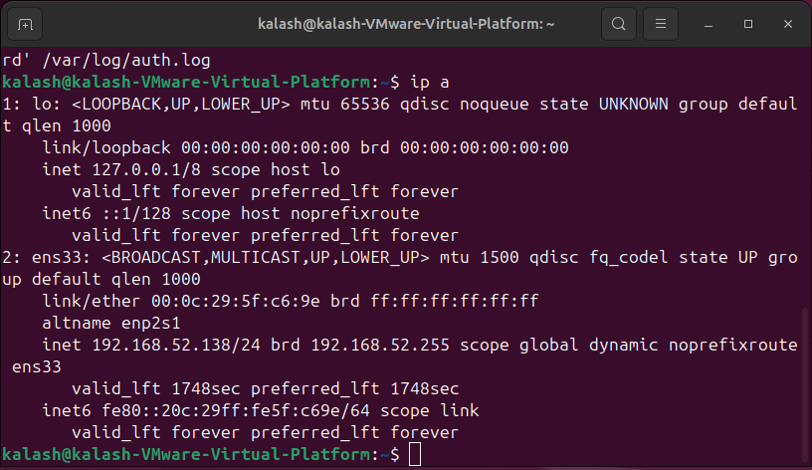
Figure 1: IP configuration of the Ubuntu system showing 192.168.52.0/24 subnet

4. Network Traffic Analysis
4.1 Environment Setup
Network traffic analysis was performed using a Linux-based virtual machine configured within a private subnet. The system was actively connected to the network and generating normal user-driven traffic.
Wireshark was used as the primary packet capture and analysis tool to observe live network activity at the packet level.
4.2 Traffic Capture
A live packet capture was conducted for approximately 10 minutes during normal system usage. The capture scope included all inbound and outbound traffic on the active network interface.
The captured data represents a baseline view of typical network behavior within a small office–style environment.
4.3 Protocol Analysis
Analysis of the captured packets showed the presence of multiple network protocols commonly observed in everyday network communication:
- TCP traffic formed the majority of the capture, primarily carrying encrypted application data.
- DNS traffic was observed during domain name resolution for external services.
- ICMP packets were generated during connectivity testing.
- ARP traffic was present within the local subnet for address resolution.
- TLS traffic confirmed the use of secure HTTPS connections.
The protocol distribution indicated normal and expected network behavior.
4.4 Traffic Patterns
Conversation-level analysis revealed that the local host generated most of the observed traffic. The system communicated frequently with external servers for DNS resolution and secure web access.
Observed traffic patterns included:
- Short-lived TCP connections
- Regular DNS queries
- Consistent traffic volume with no abnormal spikes
No suspicious communication patterns were detected during this phase.
4.5 Observations and Findings
- The captured traffic consisted primarily of legitimate DNS and HTTPS activity.
- All observed protocols and destinations aligned with expected user behavior.
- This analysis established a baseline network profile used for later incident investigation.
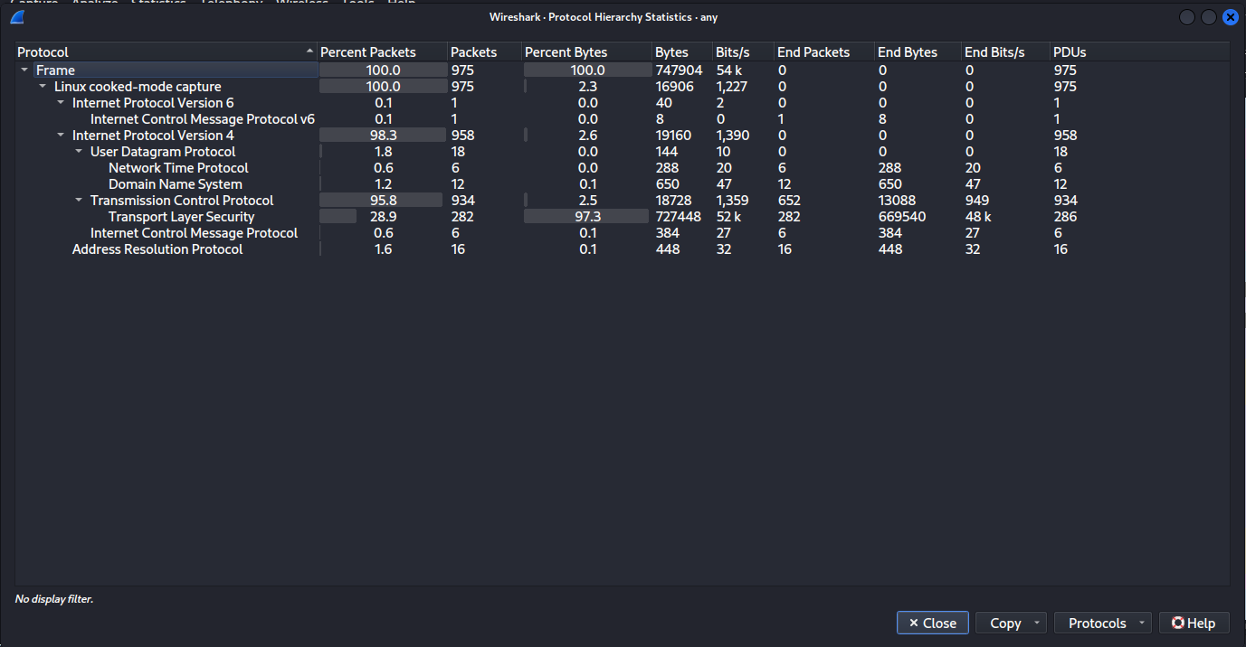
Figure 2: Protocol Hierarchy Statistics
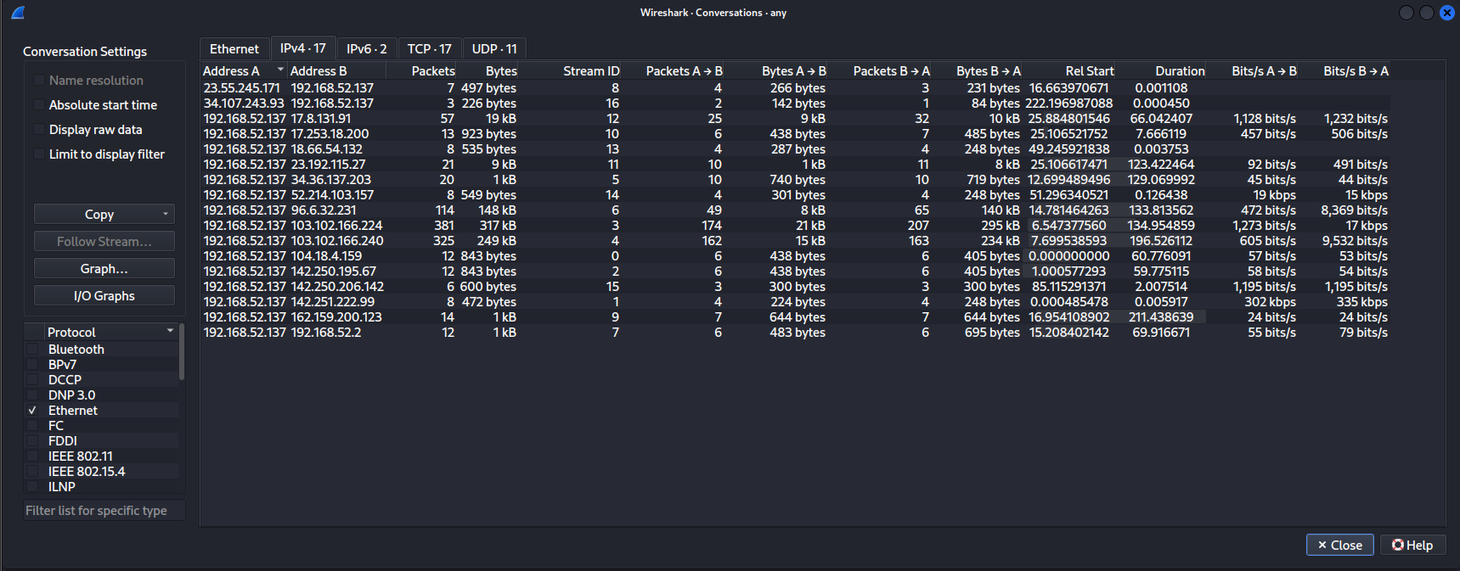
Figure 3: Conversations View
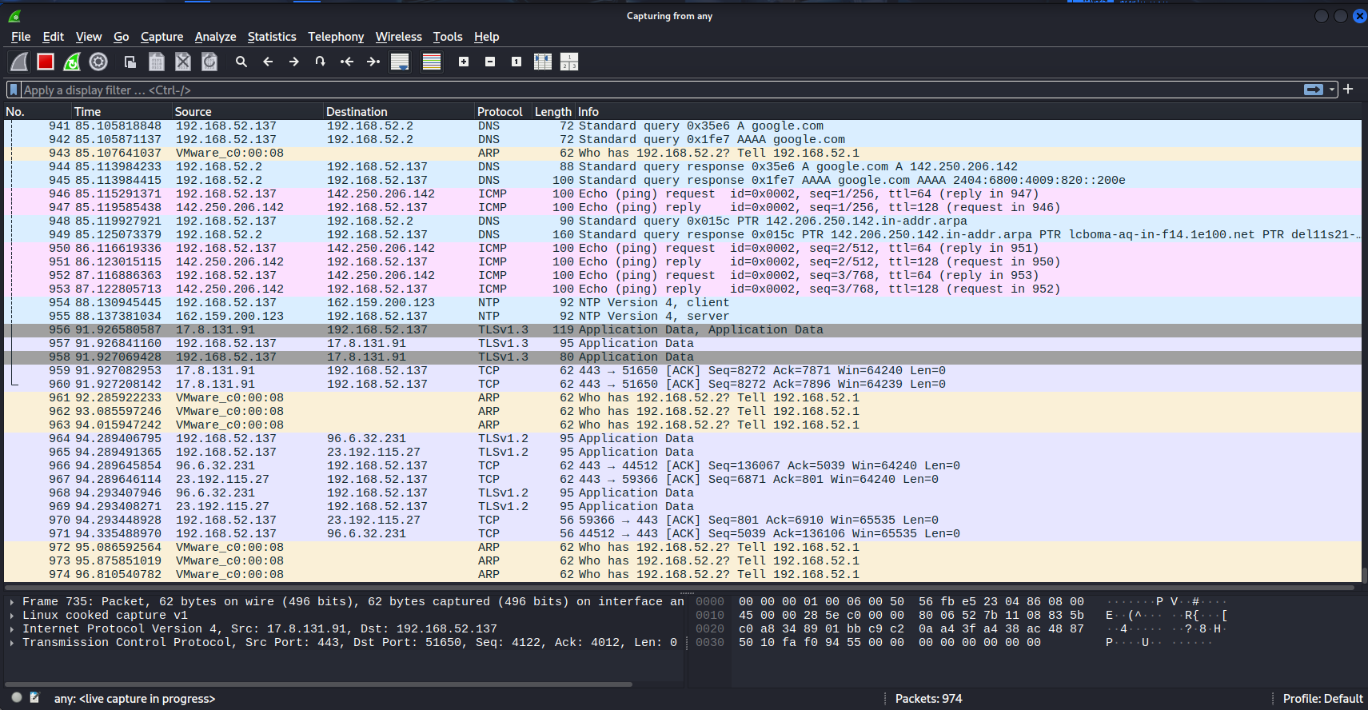
Figure 4: Packet List View

5. Network Protocol Troubleshooting
5.1 Issue Description
As part of the troubleshooting task, a DNS misconfiguration was intentionally introduced in the Linux virtual machine to simulate a common real-world network issue.
After modifying DNS settings:
- External websites could not be reached
- Name resolution failed while IP-level connectivity was still available
This scenario was used to observe protocol behavior, traffic patterns, and system logging during a DNS failure condition.
5.2 Troubleshooting Methodology
A step-by-step troubleshooting process was followed:
- Network connectivity verification was performed to confirm that the system still had a valid IP address and gateway.
- DNS behavior analysis was conducted by attempting to access websites and observing resolution failures.
- Packet-level inspection was performed using Wireshark to identify failed DNS queries.
- System log analysis was carried out to confirm that DNS-related and network activity logs were being generated.
This approach helped isolate the issue specifically to the DNS layer rather than general network connectivity.
5.3 Resolution
The issue was resolved by restoring correct DNS configuration.
Once DNS settings were corrected:
- Website access was successfully restored
- DNS queries completed normally
- Network traffic returned to expected patterns
The generated logs and packet captures during the failure window were preserved for further analysis and correlation in the SIEM platform.
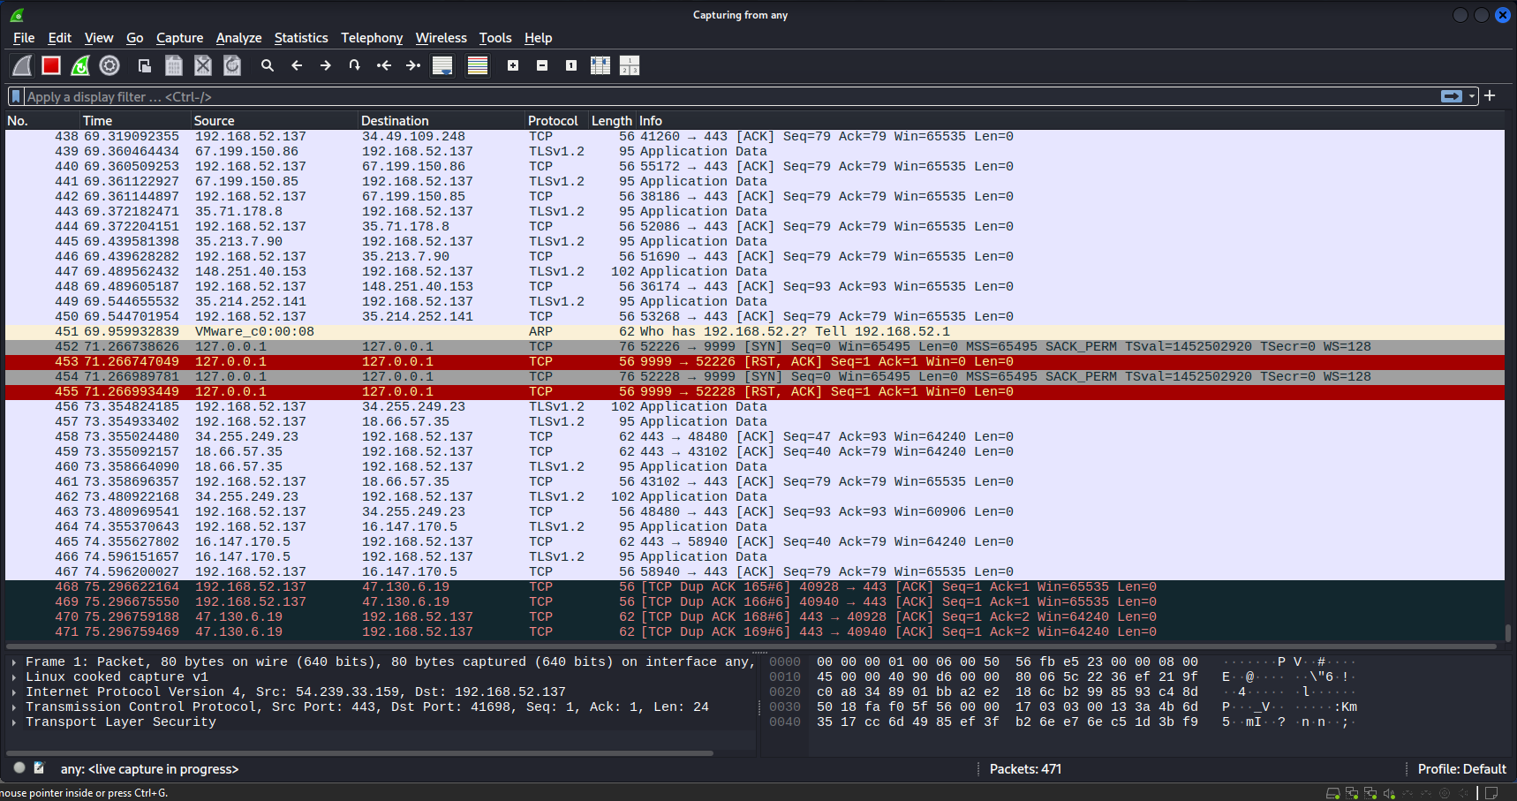
Figure 5: Packet captures during the failure

6. SIEM Setup (ELK Stack)
6.1 Architecture Overview
A centralized SIEM lab was implemented using the ELK Stack (Elasticsearch, Logstash, Kibana) on an Ubuntu Linux virtual machine.
The setup follows a single-node SIEM architecture, suitable for SOC learning and incident investigation:
- Ubuntu Linux VM – Log source and SIEM host
- Logstash – Ingests and parses system and authentication logs
- Elasticsearch – Stores, indexes, and enables fast search on logs
- Kibana – Used for visualization, filtering, and forensic analysis
This architecture allowed end-to-end visibility from log generation to incident investigation within a controlled lab environment.
6.2 Elasticsearch Setup
Elasticsearch was installed as the core data storage and search engine.
Actions performed:
- Installed Elasticsearch and enabled it as a system service
- Verified successful startup and cluster health using REST API calls
- Confirmed secure access using authenticated requests
- Validated index creation for ingested log data
Elasticsearch successfully indexed log events generated from system activity and simulated incidents.
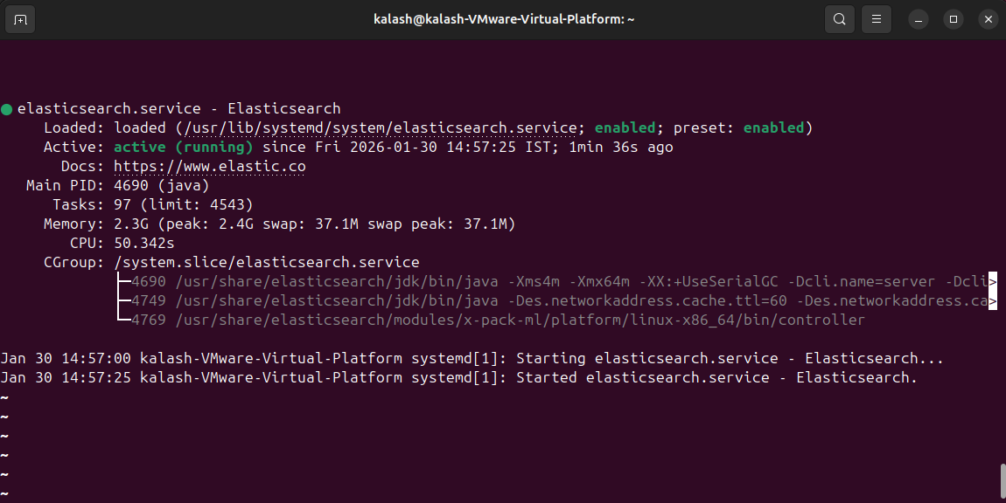
Figure 6: elasticsearch active
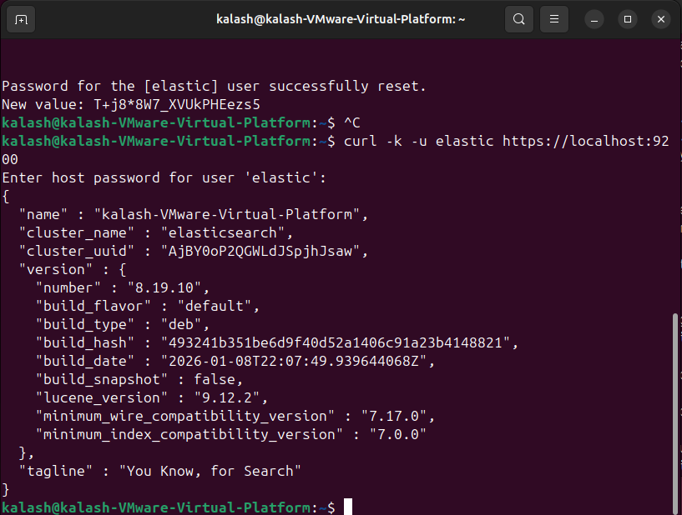
Figure 7: elasticsearch log file
6.3 Logstash Configuration
Logstash was configured to act as the log ingestion and processing layer.
Configuration details:
- Logstash was set to monitor local Linux system logs
- Logs were parsed and forwarded to Elasticsearch securely
- Custom index naming was applied to organize logs by date
- Log ingestion was verified using test log entries generated via the system logger
This ensured real-time ingestion of authentication failures, system events, and network-related logs.
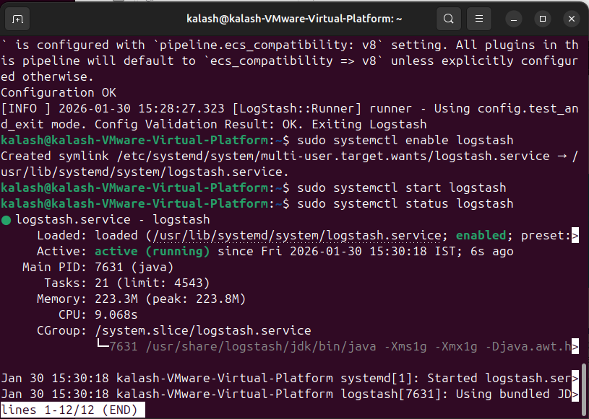
Figure 8: logstash status verification
6.4 Kibana Setup and Log Analysis
Kibana was configured as the visualization and investigation interface.
Steps performed:
- Connected Kibana to the Elasticsearch backend
- Created a data view for system log indices
- Used the Discover feature to validate log ingestion
- Applied filters to identify security-relevant events such as failed SSH login attempts
- Adjusted time ranges to correlate logs with simulated attack activity
Kibana enabled efficient investigation of incidents and supported timeline-based forensic analysis.

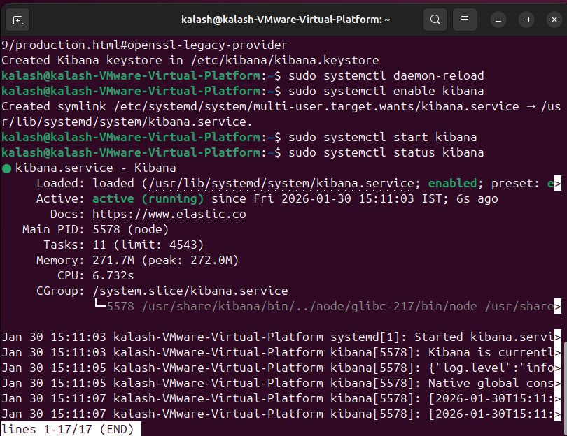
Figure 9: kibana status verification
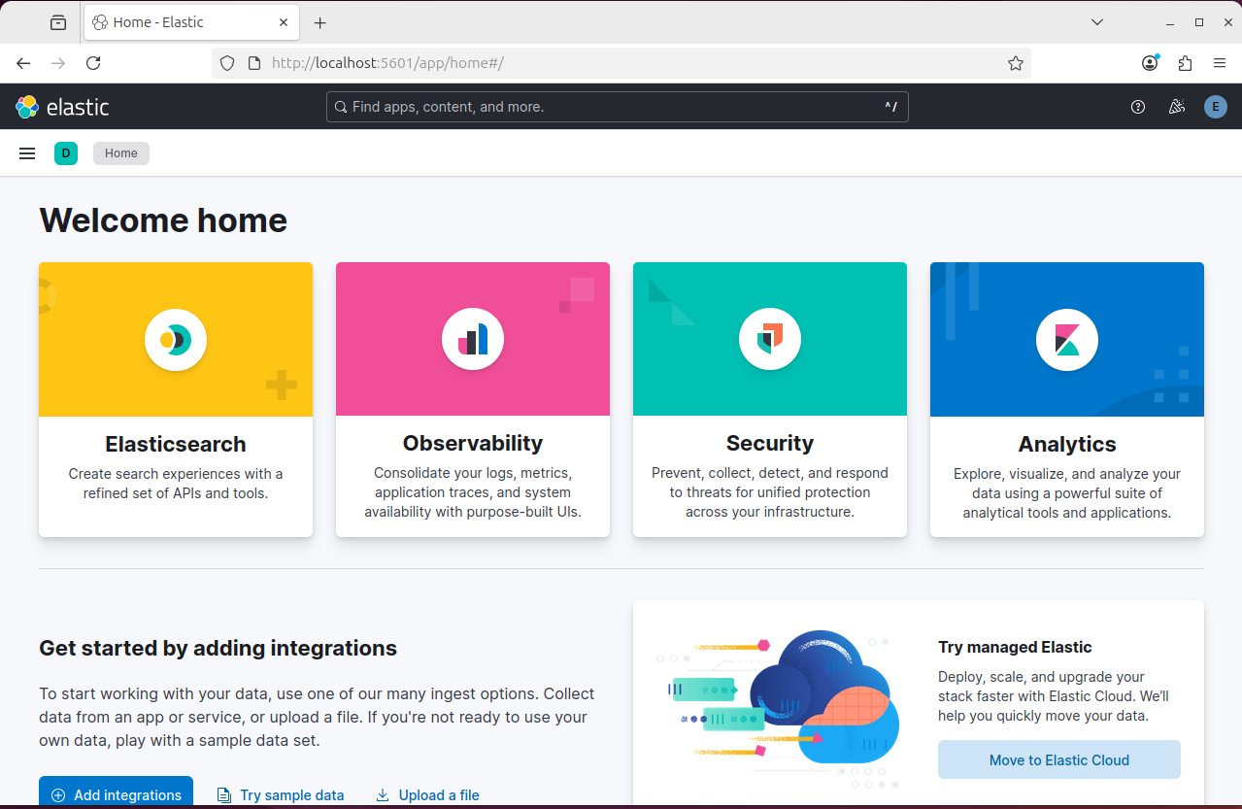
Figure 10: elastic dashboard

7. Incident Simulation and Network Forensics
7.1 Incident Scenario
A simulated security incident was performed by attempting unauthorized SSH access to the Ubuntu Linux system from a local Windows 11 machine.
The incident involved:
- Repeated SSH login attempts using an invalid username
- Intentional use of incorrect credentials
- Goal: generate authentication failures for both network-level and SIEM-level detection
This scenario represents a common real-world attack pattern such as SSH brute-force or credential probing.
7.2 Traffic Capture During Incident
During the incident, network traffic was captured using Wireshark.
Capture details:
- Traffic captured on the active network interface during SSH attempts
- Focus on SSH-related packets over TCP port 22
- Capture included connection attempts, session initiation, and termination packets
The packet capture provided visibility into the network behavior associated with the failed authentication attempts.
7.3 Forensic Analysis
Forensic analysis was performed using both packet-level data and log-level data.
Findings from network traffic:
- SSH connection attempts were observed from the Windows host IP
- Destination port identified as TCP 22
- Repeated connection attempts indicated suspicious behavior
- TCP handshake attempts were visible even though authentication failed
Findings from system logs:
- Authentication failures were recorded for an invalid user
- Source IP address matched the attacking Windows machine
- Timestamps aligned with the Wireshark capture
This confirmed that the observed network traffic directly resulted in logged security events.
7.4 SIEM Correlation and Timeline
Correlation was performed by mapping Wireshark traffic with ELK Stack logs.
Correlation process:
- SSH failure events were identified in Kibana using system log data
- Time range was adjusted to match the incident window
- Source IP, username, and event timestamps were correlated
- Network evidence and SIEM logs confirmed the same attack sequence
This correlation enabled reconstruction of a clear incident timeline, demonstrating how network activity translates into actionable SIEM alerts and forensic evidence.
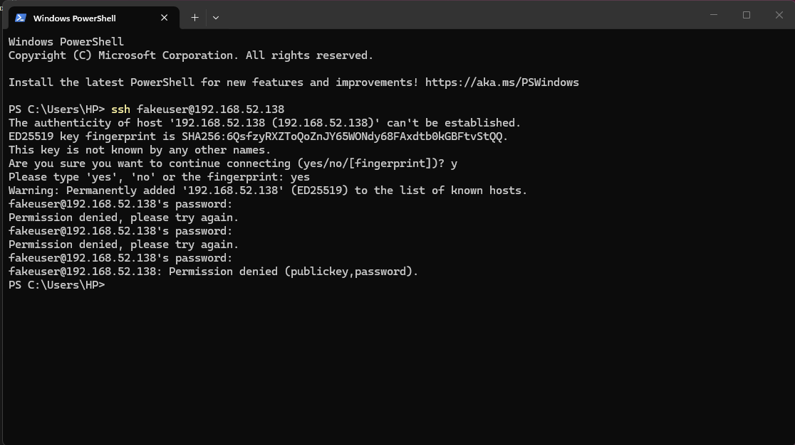
Figure 11: failed logins
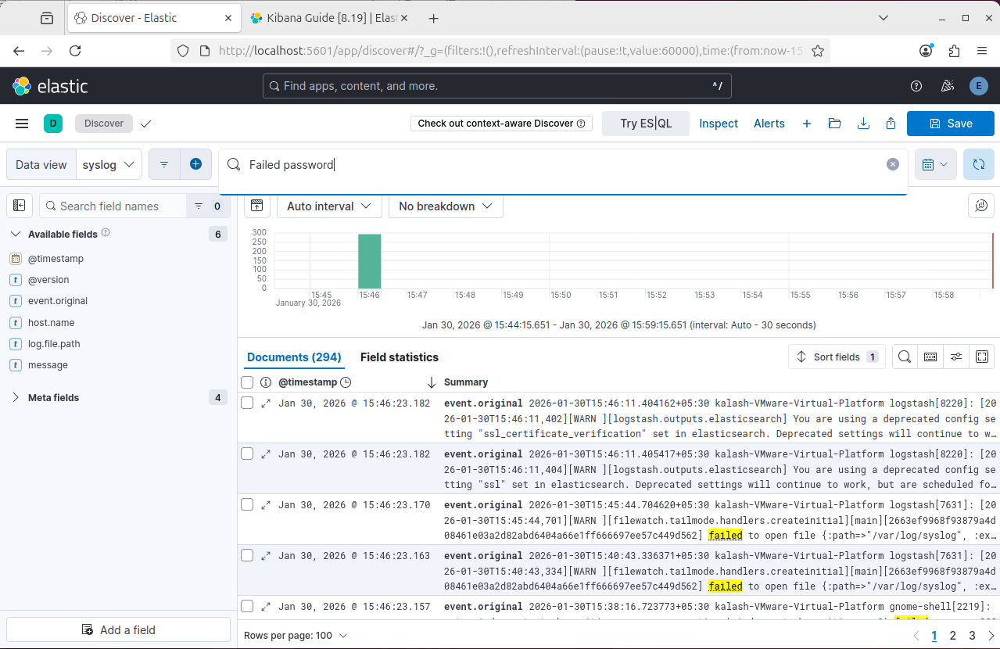
Figure 12: logs generated

8. Threat Hunting
8.1 Threat Hunting Approach
Threat hunting was performed proactively using SIEM log data and system logs ingested into the ELK Stack.
The approach focused on:
- Reviewing authentication-related logs
- Identifying abnormal or repeated access attempts
- Correlating log patterns with known attack behaviors (e.g., brute-force attempts)
Instead of waiting for alerts, logs were manually analyzed in Kibana to identify suspicious activity patterns.
8.2 Indicators of Compromise (IOCs)
During analysis, the following IOCs were identified:
- Repeated failed SSH login attempts
- Use of invalid or non-existent usernames
- Multiple authentication failures from the same source IP
- SSH access attempts targeting TCP port 22
- Short time intervals between repeated login attempts
These indicators align with common credential probing or brute-force attack behavior.
8.3 Findings
The threat hunting activity successfully identified suspicious behavior related to unauthorized SSH access attempts.
Key findings:
- The source IP matched the attacking Windows machine
- Log events were consistent across multiple failed attempts
- No successful authentication was observed, indicating the attack was unsuccessful
- SIEM visibility allowed early detection before escalation
This demonstrates how proactive threat hunting can uncover potential threats even when no critical alert is triggered.
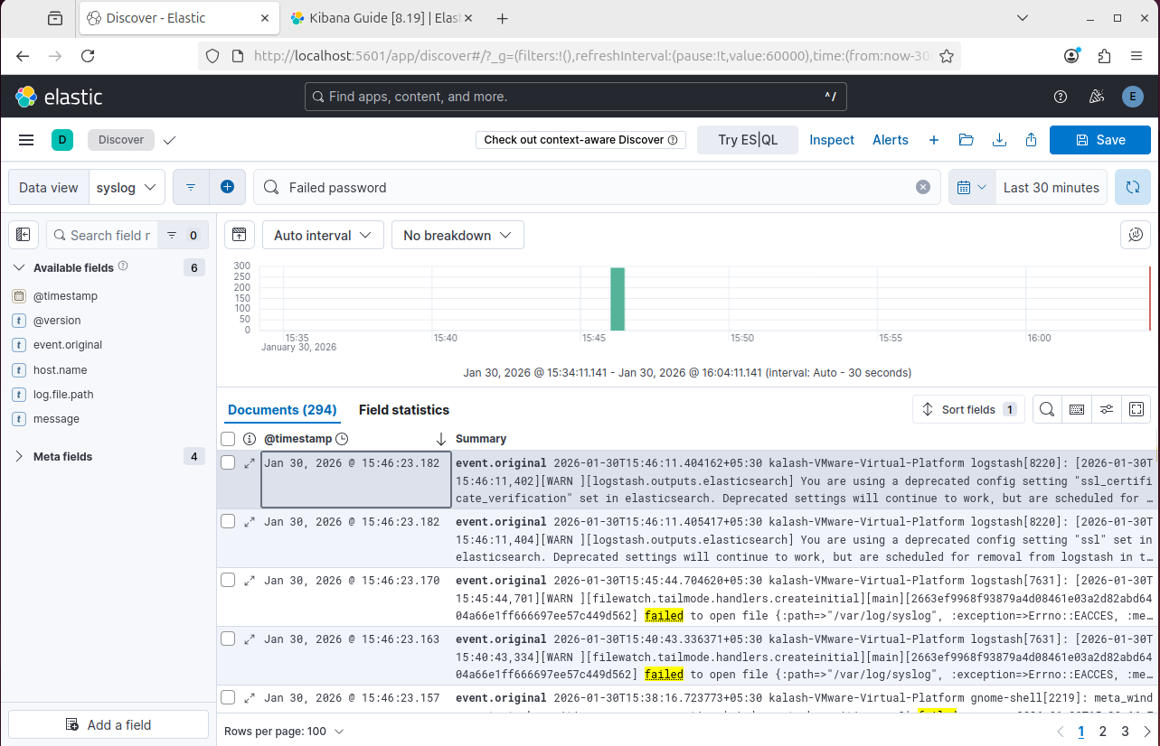
Figure 13: Failed Login Logs

9. Tools Used
The following tools and technologies were used to complete Task 05:
- Wireshark – Network traffic capture and packet-level analysis
- ELK Stack
  - Elasticsearch – Log storage and indexing
  - Logstash – Log ingestion and parsing (system logs)
  - Kibana – Log analysis, visualization, and threat hunting
- OpenSSH – SSH service for access simulation
- Ubuntu Linux – SIEM server and log source
- Windows 11 – Source machine for simulated attack activity
- Linux system logs (syslog, auth.log) – Incident and authentication analysis

10. Key Learnings
- Gained hands-on experience in correlating network traffic with SIEM logs to investigate security incidents end-to-end.
- Understood how common attacks like unauthorized SSH access appear at both packet and log levels.
- Learned to troubleshoot configuration issues in ELK and ensure reliable log ingestion and visibility for threat detection.

11. Conclusion
This task provided practical exposure to networking fundamentals, traffic analysis, and SOC operations using a real SIEM setup. By combining subnet design, packet inspection, ELK-based monitoring, and incident simulation, the task demonstrated how security events are detected, analyzed, and validated in real-world environments. The exercise closely reflects day-to-day responsibilities of a SOC analyst handling network-based threats.

